

RETURN TO THE CROSSING

Remembered with love

August 27, 2007

*By Kevin Vaughan*

*Rocky Mountain News*

More than 45 years ago, along the railroad tracks in the Auburn farming community southeast of Greeley, they experienced utter heartbreak in an instant.

A high-speed passenger train smashed into a school bus on a bitterly cold morning, killing 20 children and injuring 16 others and their driver.

The tragedy plunged an entire community into grief.

Sunday, many of them came back. Mothers and fathers who buried children after the tragedy of Dec. 14, 1961. Men and women who survived the accident but saw brothers and sisters and friends die. Classmates who have never forgotten.

They were joined by scores of others on a bright, sunny day as they formally dedicated a 2½-ton granite monument along the tracks, a spire that will forever mark the scene of the state’s worst traffic accident.

And that with its list of names will forever remind the community of what was lost.

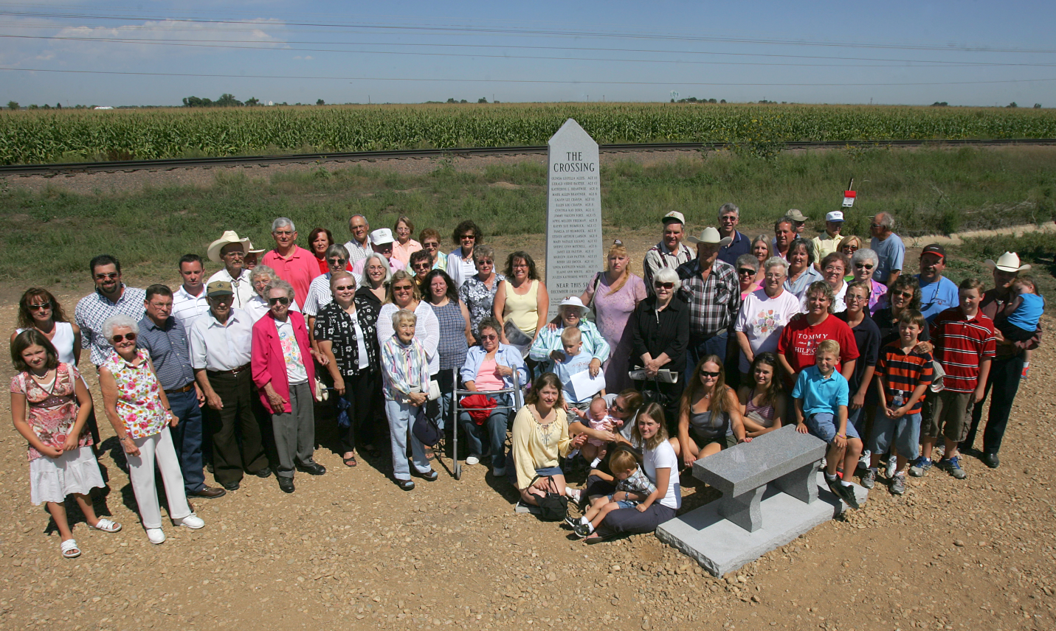

CHRIS SCHNEIDER/ROCKY MOUNTAIN NEWS

**Many of those touched by the tragedy** pose at the new memorial for The Crossing, which was dedicated to the 20 children killed in Colorado’s worst traffic accident.

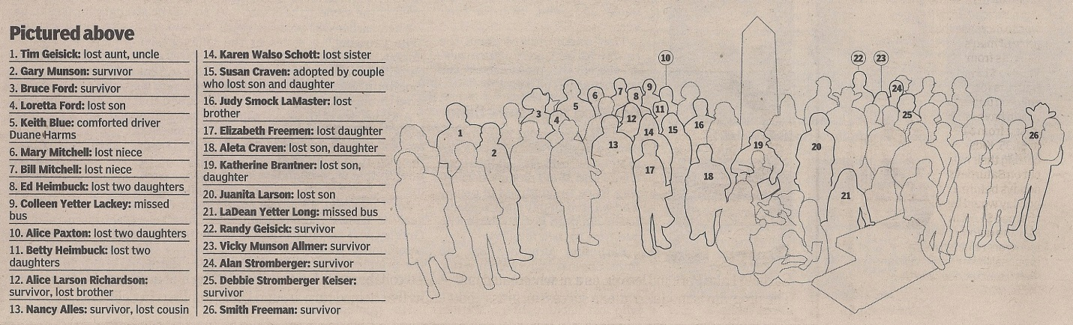

GREELEY – They gathered under a huge, cloud-dappled sky and a blazing sun, wrestling with a bittersweet tug of emotions as they remembered smiling, happy children taken from them far too soon.   
  
They dabbed at tears, managed smiles and experienced everything in between as they dedicated a granite spire in the memory of 20 children who died Dec. 14, 1961, in Colorado’s worst traffic disaster. 

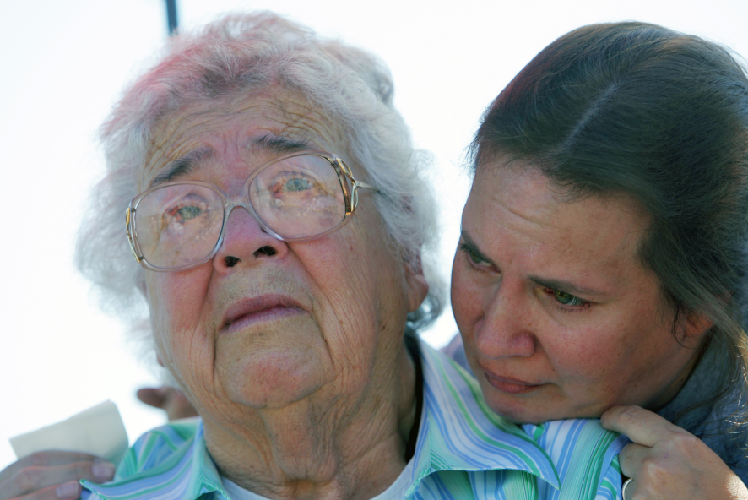They visited with people they hadn’t seen in years – decades, even – and sat quietly along a dusty road.   
  
But mostly, they remembered.   
  
And, now, nobody will ever forget.

**A different time**   
  
The story is one of almost unspeakable tragedy, of a small farming community torn open in an instant, of countless lives changed forever.   
  
That morning, with the temperature sitting at 6 degrees, a Union Pacific passenger train rocketed down the rails southeast of Greeley at 79 mph. It was an hour and 41 minutes behind schedule.   
  
Bus driver Duane Harms had 36 children on his bus as he headed to town. After stopping at a badly angled crossing, he thought the tracks were clear and pulled out.   
  
The train slashed through the bus. Only Harms and 16 of the children survived.   
  
It was a different time, and families who experienced tragedy bit their lips and pulled on their work boots and went on with their lives.   
  
They seldom talked about the heartache, and many of them never visited the place where the train smashed into the bus.   
  
**Deciding to do something**   
  
Sunday morning, in a freshly mowed pasture along Weld County Road 52, they settled into lawn chairs and stood along a barbed- wire fence – hundreds of people who wanted to pay their respects to the children lost, to those who survived, to their families.   
  
Katherine Brantner sat up front. She lost two children, a son, Mark, and a daughter, Kathy. A few feet away was Alice Paxton, who lost her daughters, Marilyn and Jan. Next to her sat Ed and Betty Heimbuck, who lost their daughters, Kathy and Pam.   
  
Scattered among the crowd were 10 of the 16 children who survived, including several who traveled from out of state. Nancy Alles Stroh from Oshkosh, Wis.; Randy Geisick from Elk Grove, Calif.; and Debbie Stromberger Keiser from Wickenburg, Ariz.   
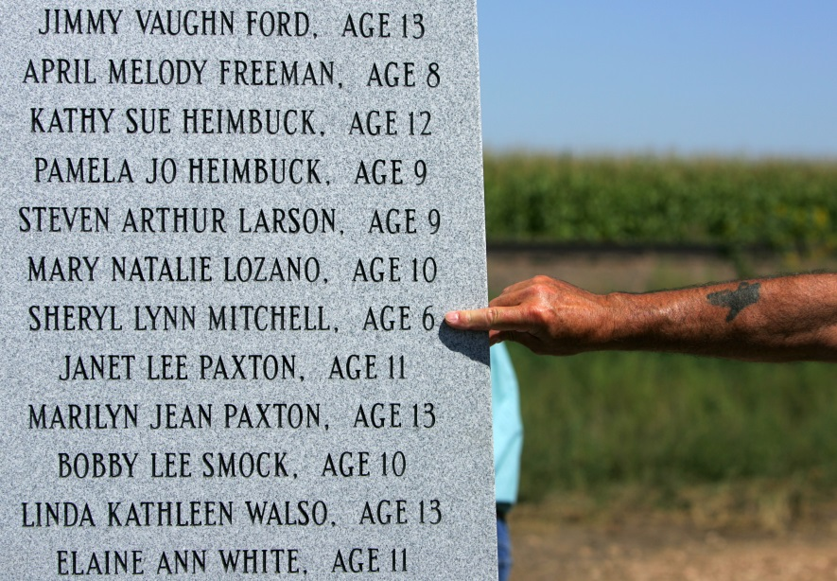  
Also present was Tim Geisick.   
  
Geisick was born after the 1961 tragedy, but Mark and Kathy Brantner would have been his uncle and aunt.   
  
Growing up, he heard little about the accident. It was just too painful for his family to talk about.   
  
For a long time, he wondered why nobody had erected a monument at the scene of the crash.   
  
Then earlier this year, he read “The Crossing,” a series in the Rocky Mountain News that chronicled the crash and the long-term effects for those who lived through it.   
  
And he decided to do something, opening a bank account and soliciting donations for a permanent memorial, overseeing a process that ended Sunday morning.   
  
Joe Tennessen, the former manager of KFKA radio station in Greeley who served as master of ceremonies, wondered aloud at the promise of those 20 lives, at what they might have accomplished.   
  
He quoted the poet John Donne – “each of us is affected by the death of any person” – and Ernest Hemingway.   
  
“All of us – including those who got here even a few years after this horrible incident and those who have come recently – are impacted by the loss of these 20 human beings,” Tennessen said.

CHRIS SCHNEIDER/ROCKY MOUNTAIN NEWS

**Mary Opatril, right, comforts** her mother, Katherine Brantner, Sunday at the site of The Crossing near Greeley. Brantner lost two children, Kathy and Mark Brantner, in the Dec. 14, 1961, crash, when a train smashed into a school bus, killing 20 children.

CHRIS SCHNEIDER/ROCKY MOUNTAIN NEWS

**Bill Mitchell points** to the name of his niece, Sherry Mitchell, on the memorial for the victims of the Dec. 14, 1961, crash that killed 20 children near Greeley.

John Temple, editor, publisher and president of the Rocky, said that a year ago he never could have imagined “that we would be standing here today together, finding comfort and strength and, I hope, some peace at the very place where the tragic accident occurred.”   
  
He paid homage to the families touched by the tragedy, who agreed to share the story of the worst experience of their lives.   
  
“It’s very important to remember that it’s only because of the courage of the families, of the survivors and those who lost loved ones, that we could be here today,” Temple said.   
  
“It’s their day.”   
  
And he said he’d learned a lesson: “It’s never too late to do the right thing.”   
  
Even though the accident was a long time ago, it still can teach people about love and loss and about the strength it takes to get up and go on after the worst that life can offer.   
  
“May that be the lesson of today here at ‘The Crossing,’ 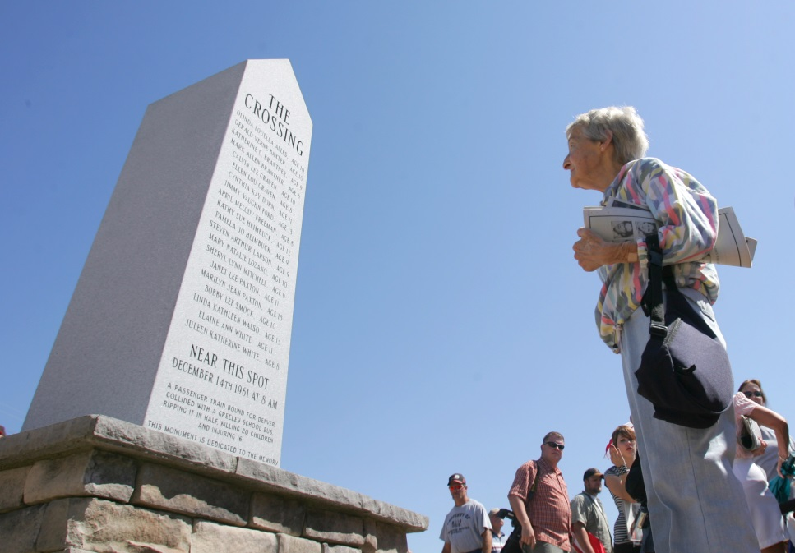that those who were lost will never be forgotten, and that we all can learn from what happened on that day,” Temple said.   
  
As Denise Ford and Boydz Boys of Greeley sang Amazing Grace a capella, you could hear a baby fussing and a tractor groaning in the distance.   
  
And then Tennessen read the names, beginning with Olinda Louella Alles, and ending with Juleen Katherine White. In between each name, he paused for a moment, and as he spoke, Bruce Ford stood quietly, holding his cowboy hat over his heart.   
  
He and his brother, Glen, were badly injured in the crash. Their older brother, Jimmy, died.   
  
And then, after a moment of silence, a white linen cloth was pulled from the granite, and people jammed in tight to look at it, to touch the names etched in black.   
  
Bill and Mary Mitchell, whose niece, Sherry Mitchell, died in the accident, snapped pictures of each other in front of the spire that sits a couple hundred feet from the spot of the collision.   
  
Aleta Craven, who lost her son, Calvin, and daughter, Ellen, sat on the bench in front of the spire and looked at it.   
  
“I think the time was right,” Bruce Ford said.   
  
Everyone gathered around the monument for a group picture. And then they stood in clumps, admiring it.   
  
“I’m just so thankful that people did it,” Juanita Larson said a little later.   
  
She had two children on the bus that morning. Her son, Steve, died and her daughter, Alice, was critically injured.   
  
Alice was there Sunday.   
  
“It was good,” she said. “It was good.”   
  
**We can point to the spot**   
  
By early afternoon, in the yard outside the home of Becky and Glen Badley, scores of people sat around in folding chairs, eating fried chicken and bratwurst and corn on the cob and peach pie, visiting.   
  
It was an old-fashioned farm picnic – plastic tablecloths and paper plates and all the food anyone could ever eat.   
  
Becky Badley was born three months after the accident that took her older sister, Linda Alles, and Sunday afternoon she said she was pleased with everything – that the lost children were remembered, that a monument marked the scene of a tragedy that changed her family and many others forever.   
  
“People will always ask, ‘Where did that happen?’” she said. “Now we can point and say, ‘It was right there.’”   
  
Across the lawn, Judy Smock LaMaster, whose younger brother, Bobby Lee, died in the accident, talked about what it meant to her.   
  
“I’m just glad they finally, after all these years, remembered those kids,” she said. “I just bet my mom and dad and everyone else who had kids on that bus are smiling in heaven today.”   
  
By midafternoon, the last car had pulled out of Becky and Glen Badley’s yard.   
  
Two miles away, at the crossing, a Buick pulled off the road, two people inside.   
  
They sat there, looking out the window at the monument before finally driving off.   
  
**No more years of silence**   
  
When Gary Munson was a little boy, silence shrouded the tragedy of Dec. 14, 1961.   
  
He had been sitting up front in the bus that morning, across from his brother, John, and sister, Vicky, and he’d come away bumped and bruised but basically unharmed.   
  
His brother and sister also survived, but he never brought up the accident, and nobody else did, either. Ever.   
  
And even when he wanted to reflect on what he went through, he couldn’t. He would walk down the main hall at East Memorial Elementary School, and he would stop in front of the brass plaque in the front hall listing the names of the 20 children who died on his school bus, and he would hear the voice of a teacher after just a moment or two: “You better get going” or “Shouldn’t you be in class?”   
  
“At the time,” he said Sunday, “I didn’t think much of it.”   
  
Now it’s different. Now he can sit on the bench dedicated to the survivors – dedicated to him – and he can look at the list of names carved into the granite, and he can think about it for as long as he wants.   
  
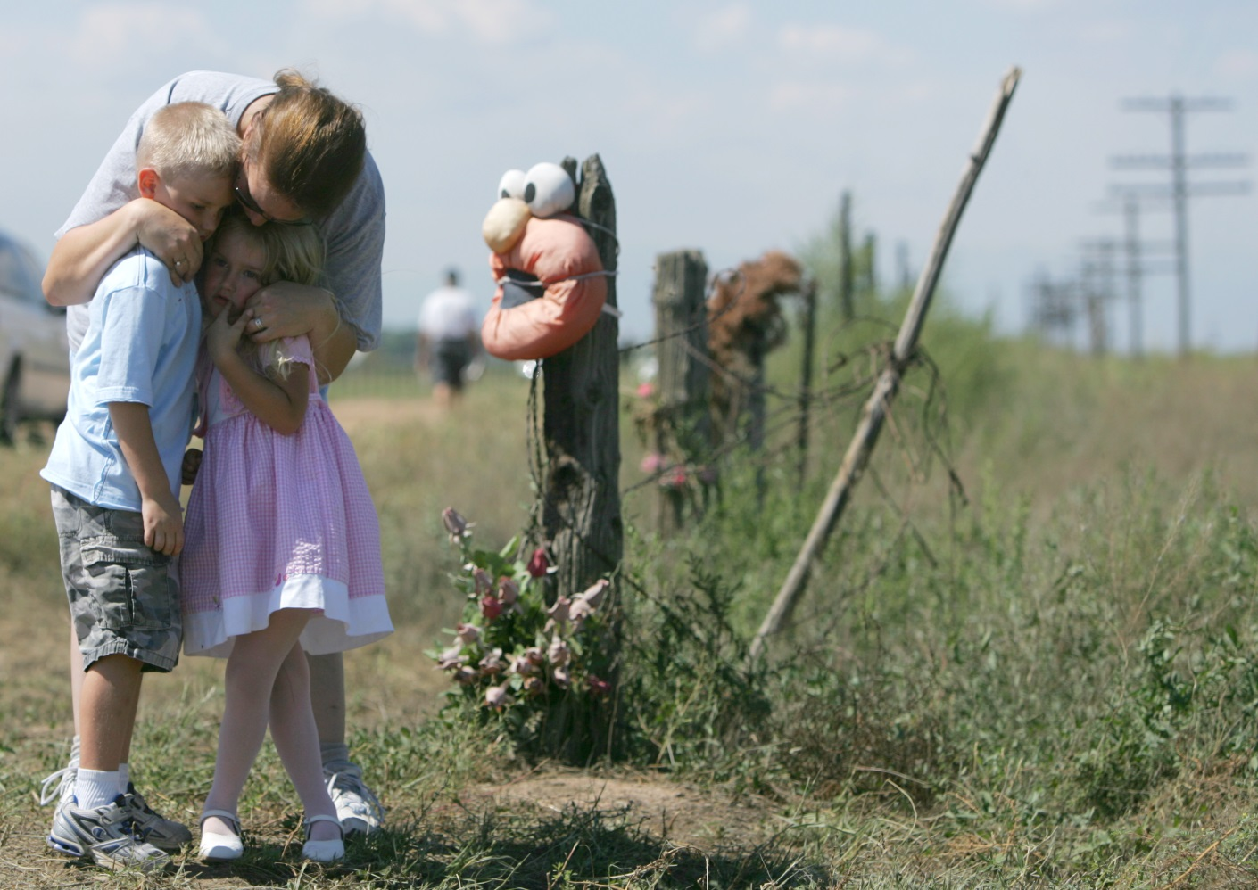

CHRIS SCHNEIDER/ROCKY MOUNTAIN NEWS

**Elizabeth Freeman,** right, examines The Crossing memorial. She had three children on the bus that was hit by a train. April Melody Freeman was killed, but Smith and Joy Freeman survived.

CHRIS SCHNEIDER/ROCKY MOUNTAIN NEWS

**Mary Opatril hugs her grandchildren** Alexander Fabian, left, 5, and Grace Fabian, 4, Sunday near Greeley at the scene of a train-school bus collision that killed 20 children Dec. 14, 1961. Opatril’s brother and sister, Mark and Kathy Brantner, died in the crash.

**About the series**  
  
In just seconds, 20 children died and a community was devastated.   
  
At 7:59 a.m. on Dec. 14, 1961, a high-speed passenger train smashed into a school bus carrying 36 students in the farm country of Weld County. It was the worst traffic accident in Colorado history. Only 16 children and the bus driver survived.   
  
We cannot know how today’s tragedies – Columbine, Oklahoma City, Sept. 11 – will ripple over a lifetime.   
  
But 45 years after that bitter cold morning outside Greeley, we can see – if not fully understand – how a single moment has the power to uncoil through decades, shaping people for the rest of their lives.   
  
**Online**  
  
* Video: 22 documentary videos that feature interviews with survivors, family and friends; historical photos and film footage; news and family photographs   
  
* Slide shows: 34 slide shows with additional photographs, including current portraits, family photos and historical news photos   
  
* Documents: Affidavits, accident reports, letters from the public, material from the district attorney’s file   
  
* Annotations: Footnoted versions of the stories listing sources of information   
  
* Print pages: Images of the newspaper version of each chapter   
  
* Response: Reader comments posted online at RockyTalk Live   
  
* Forum: Video of a public forum held Feb. 21 in Greeley by a team of Rocky staffers who worked on The Crossing . The forum attracted 700 people. Also, video of a forum held March 7 at the Rocky headquarters building in Denver. 

CAPTION: Linda Alles, 10   
CAPTION: Kathy Brantner, 9   
CAPTION: Mark Brantner, 6   
CAPTION: Melody Freeman, 8   
CAPTION: Ellen Craven, 8   
CAPTION: Cindy Dorn, 11   
CAPTION: JimmyFord, 13   
CAPTION: Kathy Heimbuck, 12   
CAPTION: Ellen Craven, 8   
CAPTION: Pam Heimbuck, 9   
CAPTION: Steve Larson, 9   
CAPTION: Juleen White, 8   
CAPTION: Mary Lozano, 10   
CAPTION: Sherry Mitchell, 6   
CAPTION: Jan Paxton, 11   
CAPTION: Marilyn Paxton, 13   
CAPTION: Bobby Smock, 10   
CAPTION: Jerry Baxter, 10   
CAPTION: Calvin Craven, 10   
CAPTION: Linda Walso, 13   
  
*Edition: Final  
Section: News  
Page: 6NEWS  
Donated to the Denver Public Library by the Rocky Mountain News, under the permission of the City and County of Denver, other rights reserved. Copyright © 2007 Rocky Mountain News. All Rights Reserved.*

*Contact the Western History/Genealogy Department, Denver Public Library, for permission to publish.*